Notes on INSERT Commands

--InsuranceProvider

--Residence

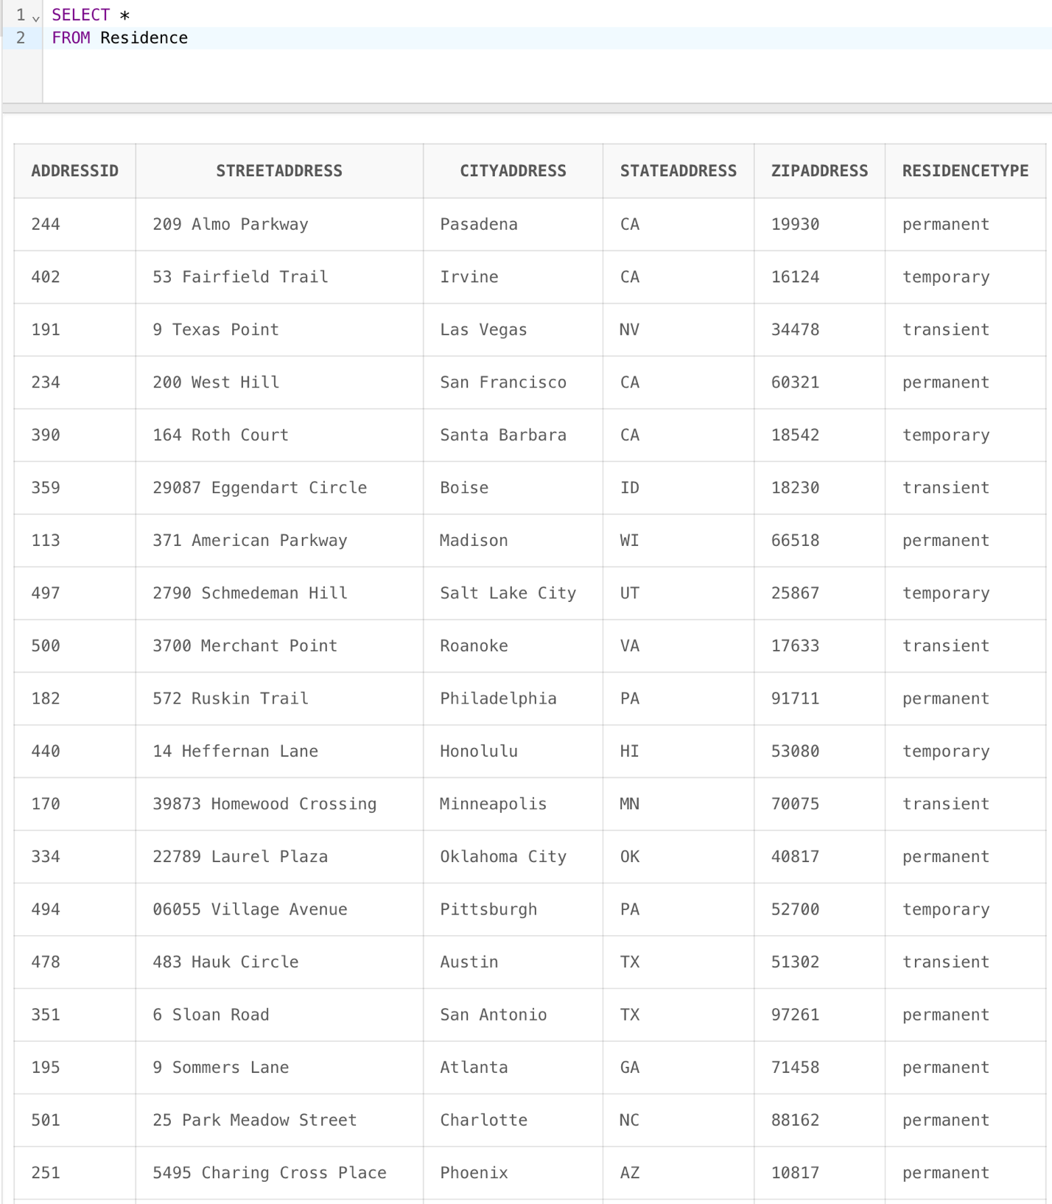

--Allergy

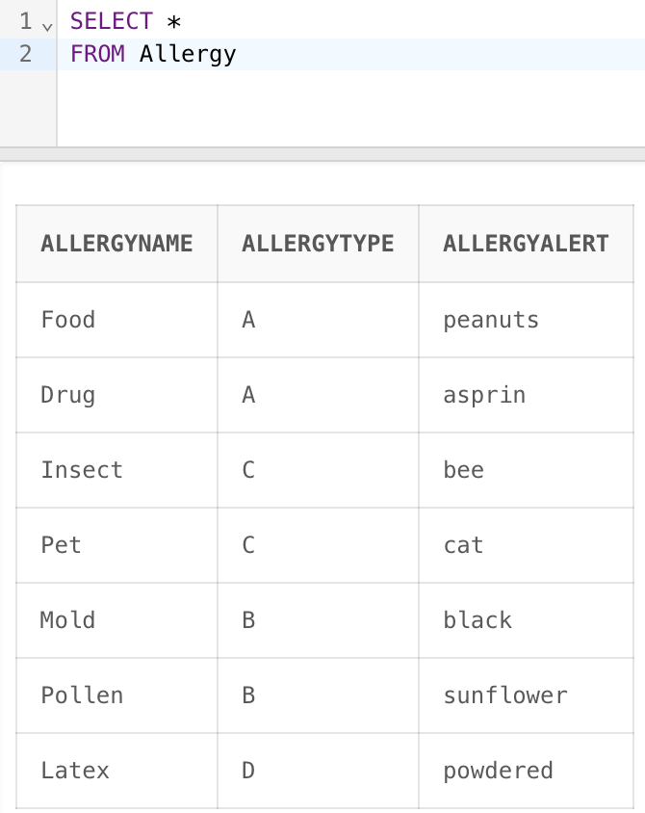

--ChronicCondition

--ServiceListing

--Equipment

--PaymentMedium

--Patient

--Guardian

--HealthInsurancePolicy

--CharitableOrganization

--GuardianPayment

--Payment

--Guardianship

--PatientAllergy

--PatientCondition

--PatientVisit

--PastSurgery

--EquipmentUsed

--FutureAppointment

--ServiceAtVisit

